GIT installation & commands implementation

Problem Statement:

To understand GIT Installation, project check-in and checkout actions

Steps to execute:

1) Install Git.

To check that Git installed: type git –version in command prompt. It will display the git version.

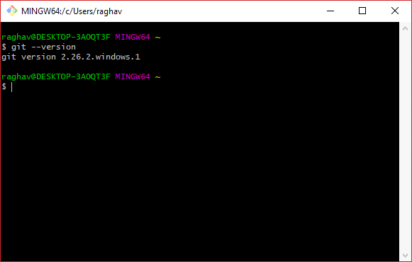

Configure username and Password using git configure command.

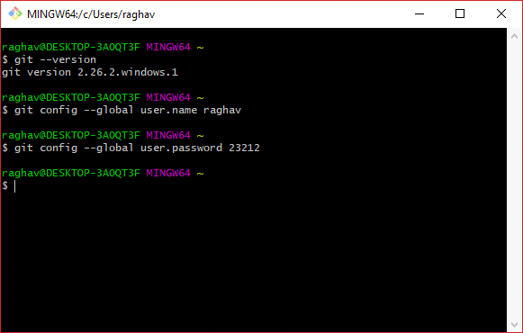

2) Use a Java case study and perform the following actions in Git.

Do check in:

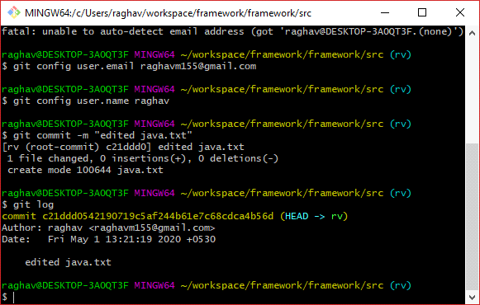

check out:

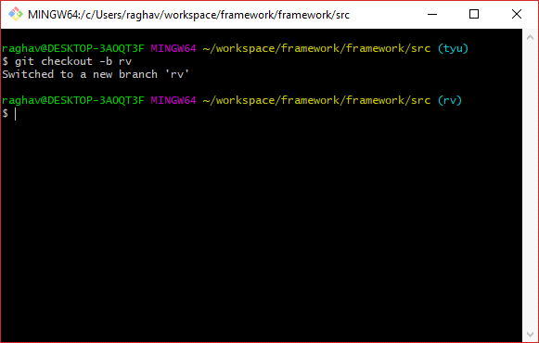

Merge:

